Make up requirements for Legally Blonde
Please note that ALL students will be required to wear stage makeup for the production – both boys and girls. The pictures included below are examples of the type of items required.

Each student will be required to supply the following:

Base Makeup/Foundation
Please note that stage make up is required otherwise you will fade out under the stage lighting. Please note that stage makeup is heavier than everyday makeup. You will require a panstick or pancake style base makeup or foundation that is slightly darker than what you would wear for everyday use.
Please see photo below for an example:
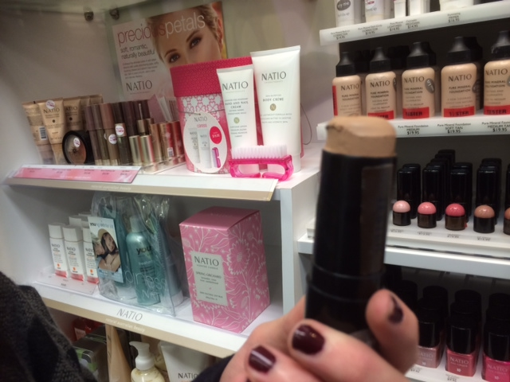
Relatively inexpensive ($12-$15) versions of this are available in Natio and Maybeline brands at National Pharmacies.

Eyeliner
All students (boys and girls) will also require a black or dark brown kohl pencil or eyeliner pencil to define eyes. It is IMPERITIVE that all students supply their own eye makeup. It is very unhygienic to share eye-makeup and infections easily occur.
Example below. Available from National Pharmacies at cost between $5-$8
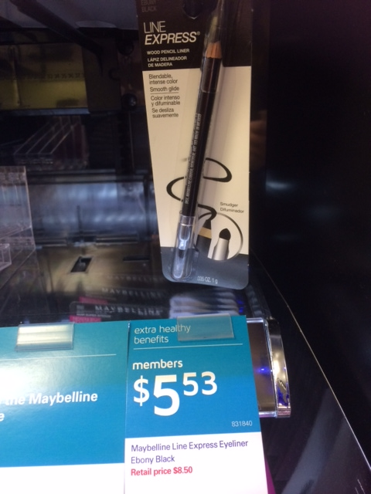

Cheek Colour
Students will also require blush or similar cheek colour to define and contour the face. This should be a reddish brown colour rather than a rose pink.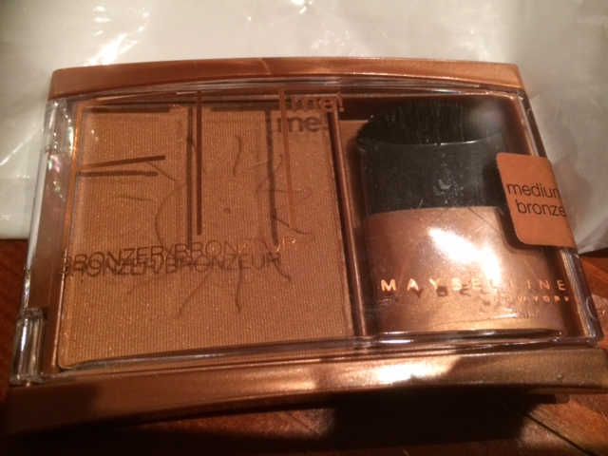

Lip Colour
All girls will require a lipstick that is suitable to the rest of their look. Please bring along any options you already have that you feel may work and we will confirm their suitability.
Boys will not be required to wear lip colour.

Make Up Remover and Tissues
Make up wipes - $5 - $7 Supermarkets/Chemists
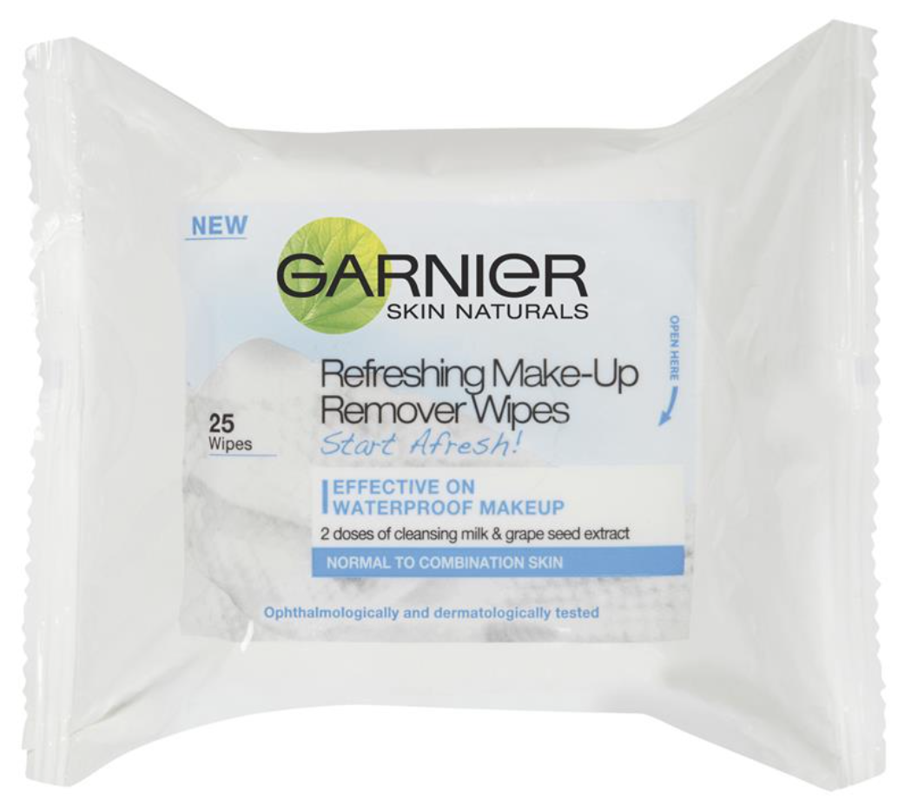

Storing Make Up
Each personal make up item should be named and stored in a named, sealed container (eg, lunchbox/Tupperware container). The make up box should then be stored in the students large costume box.

Each student is responsible for applying and looking after their own make up.

